**Task 1**

**Objective:**

Write a C++ Program that whether the two arrays are equal or not.

Declare two Integer Arrays with 7 elements, and fill up the array with keyboard input.

Test if every element in Array 1 is equal to corresponding element in Array 2. For example, the program should check A[0] = B[0], A[1] = B[1], and so on.

**PROGRAMMING**

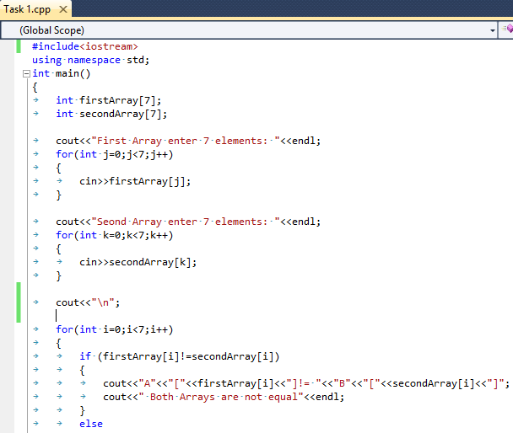

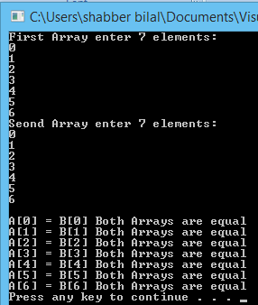

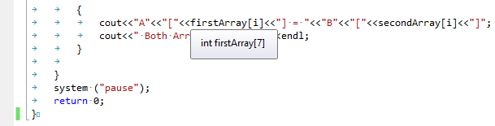

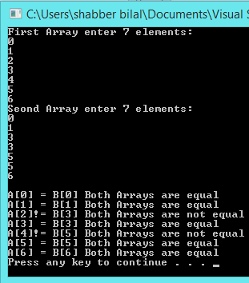

**Task 2**

**Objective:**

Write a C++ program to calculate the sum of each row, column of (2D) array of size 3x3

**PROGRAMMING**

